**தொழில்நுட்பக் கல்வி இயக்ககம்  
Directorate of Technical Education**

**Government of Tamil Nadu**



**Regulation 2023**

**IPEC Framework**

**(Integrated Pedagogy of Experiential Curriculum)**

***A Framework for Lab-Theory Integrated, Outcome-Based Experiential Learning***

**Department of Computer Engineering**

**LAB MANUAL**

**Course Name: COMPUTER HARDWARE AND NETWORKING**

**Course Code:** **1052235440**

**Course Type: Practicum**

**Year/Sem: III / V**

**Directorate of Technical Education (DOTE), 53, Sardar Patel road, Guindy, Chennai – 600025.**

**List of Experiments**

**PART – A**

1.Hard Disk/SSD

a) Partition and Format.

b) Scan Disk, Disk Cleanup, Disk De-Fragmentation

2. Install and configure any one device (Printer, Scanner, Webcam, Bio-metric

   device) with system and troubleshoot the problems.

3.Server OS installation

4.Installation and configuration of DNS Server

5.Installation and configuration of DHCP Server

**PART – B**

6. Installation and Configuration of any one of Service

    (Telnet, FTP Server, Web Server)

7.Practice the following cabling works in a network

a) Cable Crimping  b) Standard Cabling

c) Cross Cabling  d) Testing the Crimped cable using a Cable tester

8.Create a Network topology using any network simulation software.

9.IP Configuration & Testing

a) Configure Host IP, Subnet Mask and Default Gateway in a system in

LAN (TCP/IP Configuration).

b) Configure Internet connection and use IPCONFIG, PING / Tracert and

    Netstat utilities to Debug the Network issues.

10. Data Backup & Network Security

a. Create and configure user accounts (Administrative and Standard) in Windows.

b.   Create automated backups to ensure no data loss & you always have a recent backup

c.   Create rules on firewall to allow clients to connect to the Server Service

| **SCHEME OF VALUATION** | | |
| --- | --- | --- |
| **SNO** | **ALLOCATION** | **MARKS** |
| 1 | Aim (05) ,Procedure from Part – A  (30) | 35 |
| 2 | Aim (05) ,Procedure  from Part – B  (30) | 35 |
| 3 | Executing any one from (Part A or Part –B) | 15 |
| 4 | Output | 10 |
| 5 | Viva Voce | 05 |
| 6 | Total | 100 |

| **EX.NO: 1** | **HARD DISK / SSD - DISK MANAGEMENT ESSENTIALS** | **Date:** |
| --- | --- | --- |

**AIM:**

To understand and perform basic maintenance tasks on a hard disk or SSD including:

* Partitioning and formatting a drive
* Using built-in Windows tools: Scan Disk (Error Checking), Disk Cleanup, and Disk Defragmenter

**PROCEDURE:**

**Partition and Format a Hard Disk / SSD**

1. **Open Disk Management**
   * Press Win + X and select **Disk Management**
   * OR type **Create and format hard disk partitions** in the Start menu
2. **Create a New Partition**
   * Right-click on **Unallocated Space**
   * Choose **New Simple Volume**
   * Follow the **wizard** to:
     + Assign a **drive letter**
     + Choose **NTFS** file system
     + **Format** the volume

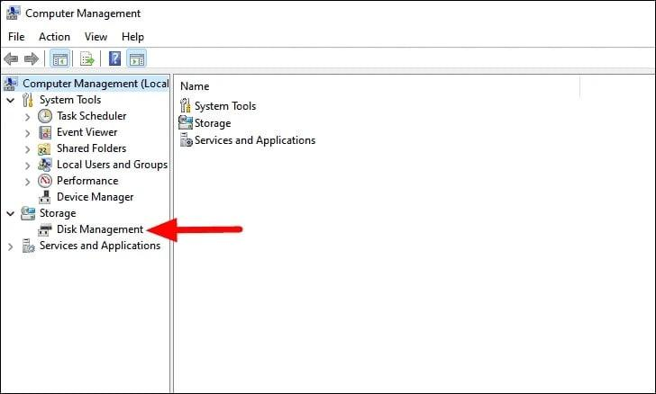

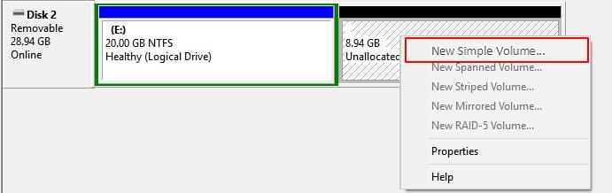

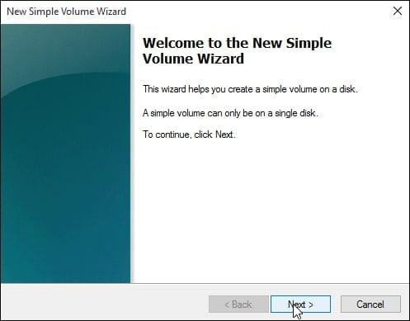

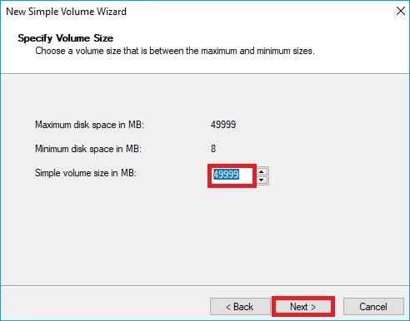

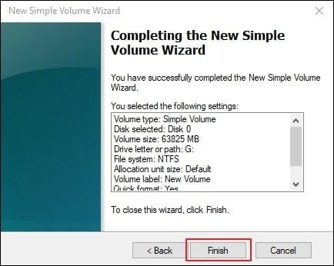

1. **Format an Existing Partition**
   * Right-click on an existing partition
   * Select **Format**
   * Choose file system: NTFS or exFAT
   * Optionally label the drive

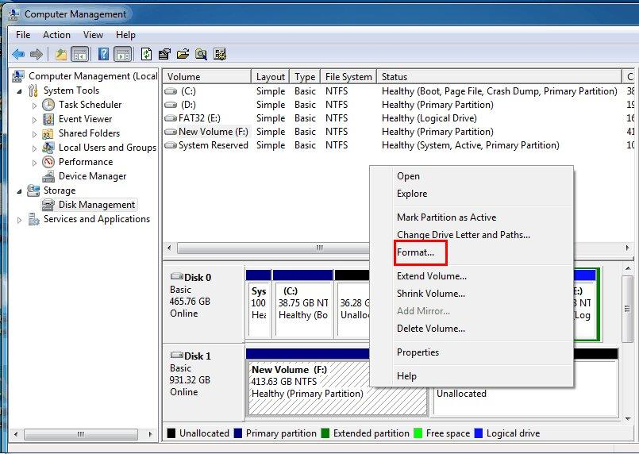

**Use Scan Disk, Disk Cleanup, and Defragmentation Tools**

1. **Scan Disk (Error Checking)**
   * Open **File Explorer**
   * Right-click on a drive (e.g., D:) → **Properties**
   * Go to **Tools** tab → Click **Check** under "Error Checking"
   * Choose **Scan drive**

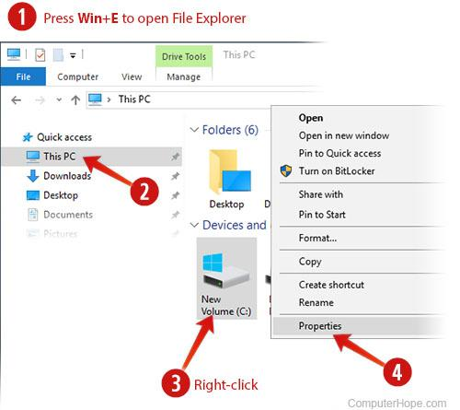

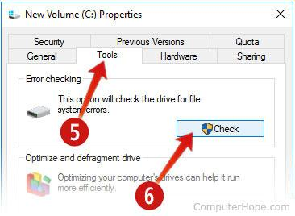

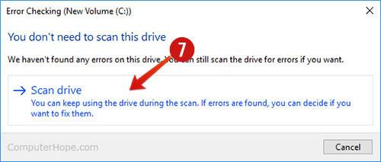

1. **Disk Cleanup**
   * Press Win + S, type **Disk Cleanup**
   * Select a drive (usually C:) → Click OK
   * Choose items to clean (Temporary Files, Recycle Bin, etc.)
   * Click **OK** → **Delete Files**

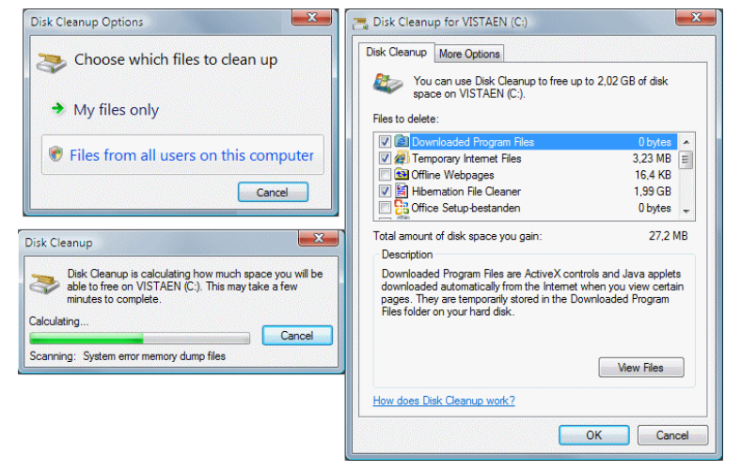

1. **Disk Defragmentation**
   * Press Win + S, type **Defragment and Optimize Drives**
   * Select the drive → Click **Optimize**
   * Wait for the process to complete

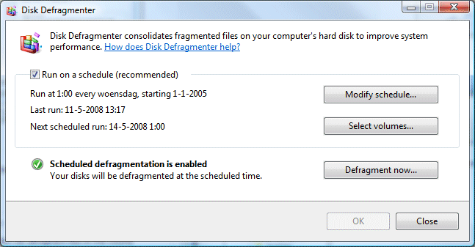

**RESULT:** Thus the storage device **has been** successfully **partitioned and formatted**, its file system **scanned for errors**, disk space **freed up** through cleanup, and its performance **optimized** via defragmentation.

| **EX.NO: 2** | **INSTALLING AND CONFIGURING A PRINTER ON WINDOWS** | **Date:** |
| --- | --- | --- |

### **AIM:**

To install, configure, and troubleshoot a **printer device** on a Windows system and ensure successful operation.

## **PROCEDURE:**

### **Step 1: Connect the Printer**

* **USB Printer**: Connect the printer using a USB cable
* **Network Printer**: Connect via Wi-Fi or Ethernet to the same network as the PC

### **Step 2: Install Printer Drivers**

* Go to **Settings → Devices → Printers & scanners**
* Click **Add a printer or scanner**
* Windows will search for the printer
  + If detected, click **Install**
  + If not, click **The printer that I want isn’t listed**, then follow the wizard
* If needed, download the latest driver from the **manufacturer's website** (e.g., HP, Canon, Epson)

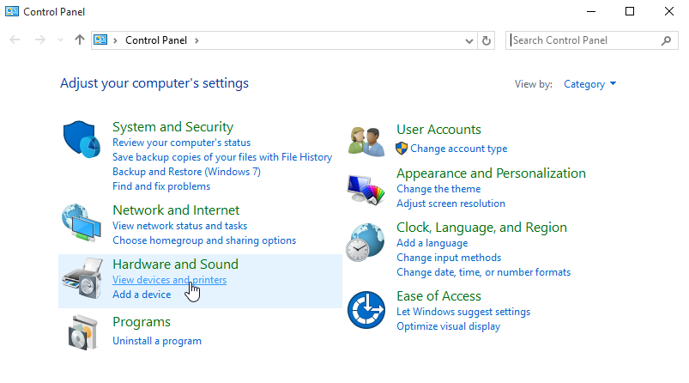

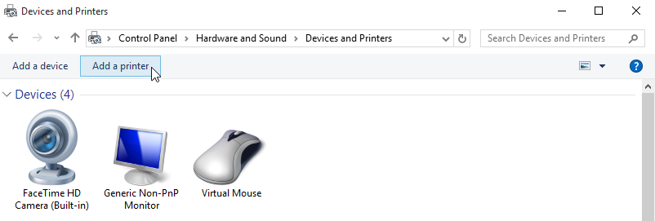

### **Step 3: Test the Printer**

* After installation, click the printer name
* Choose **Manage → Print a Test Page**
* Confirm that the printer prints successfully

### **Step 4: Troubleshooting**

### **Problem 1: Nothing Happens When You Try to Print**

**Possible Causes:**

* Paper is not loaded properly
* Paper jam or misfeed inside the printer

**Solutions:**

* Ensure paper is placed correctly in the paper tray
* Open the printer cover and check for any stuck paper or obstructions
* Remove any jammed paper carefully and reload

### **Problem 2: Printer Has Paper and No Jam, But Still Won’t Print**

**Possible Causes:**

* Software or communication error
* Stalled or corrupted print job

**Solutions:**

* Cancel the current print job from the computer's print queue
* Use the **Restart** or **Cancel Job** button on the printer (if available)
* Turn the printer off, wait a few seconds, and turn it back on
* Try printing a test page again

### **Problem 3: Print Output Is Faint or Unreadable**

**Possible Causes:**

* Low ink or toner
* Incorrect print quality settings

**Solutions:**

* Check ink/toner levels using the printer’s control panel or computer software
* Replace the ink cartridge or toner if it’s low or empty
* Refer to the printer's instruction manual for compatible cartridge types
* Adjust print settings to a higher quality mode if needed

### **RESULT:**

The printer was successfully installed, configured, and tested.

| **EX.NO: 3** | **INSTALLATION OF WINDOWS SERVER 2019/2022 OS** | **Date:** |
| --- | --- | --- |

### **AIM:**

To install the Windows Server 2019/2022 operating system on a computer system.

### **REQUIREMENTS:**

* A computer (64-bit architecture, virtualization-enabled).
* Bootable USB/DVD with Windows Server 2019 or 2022 ISO.
* Basic knowledge of BIOS/UEFI and disk partitioning.

### **PROCEDURE:**

**Pre-Setup:**

1. Insert the **Windows Server 2019/2022 USB/DVD** into the system.
2. **Restart the system** and enter BIOS/UEFI settings.
3. Set the **first boot device** to USB or DVD.
4. Save settings and exit (**usually F10**).

**Installation Steps:**

**Step 1:** Boot the system. Press any key when prompted: “Press any key to boot from CD or DVD…”

**Step 2:** On the **Windows Setup screen**, choose:

* Language to install
* Time and currency format
* Keyboard or input method  
  Click **Next** → **Install Now**.

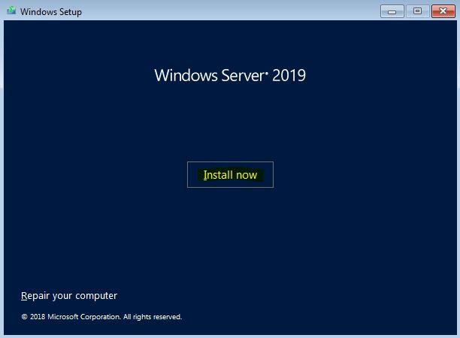

**Step 3:** Setup will start loading files.

**Step 4:** Choose the edition to install (e.g., **Windows Server 2022 Standard/Desktop Experience**), then click **Next**.

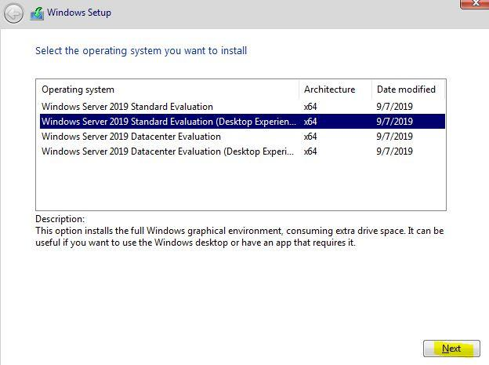

**Step 5:** Accept the **License Agreement** and click **Next**.

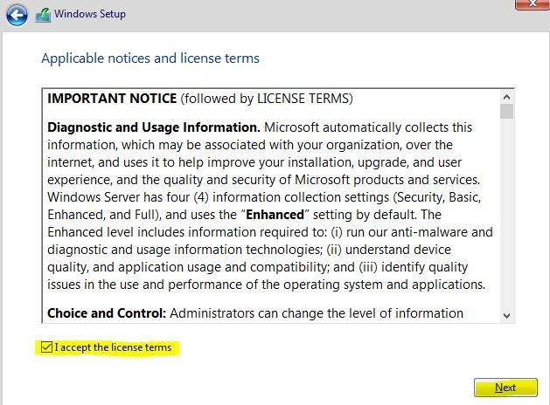

**Step 6:** Choose **Custom: Install Windows only (advanced)**.

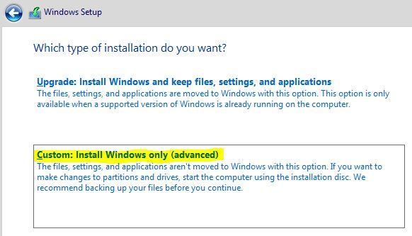

**Step 7:** On the **Where to Install Windows?** screen:

* Select the disk with unallocated space.
* Click **New** to create a partition.
* Click **Apply**, then **Next** to install on that partition.

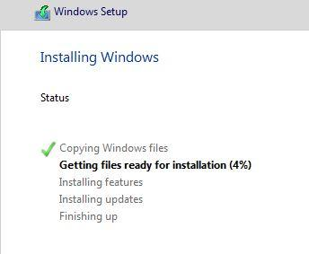

**Step 8:** The system will begin **copying and installing files**.  
This may take several minutes and the system will **restart automatically**.

**Step 9:** After restart, you’ll be prompted to **set the Administrator password**.  
Enter a strong password and click **Finish**.

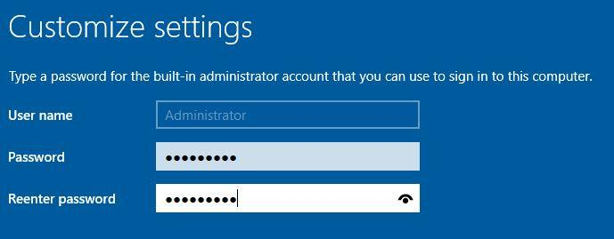

**Step 10:** Press **Ctrl + Alt + Delete** to sign in.

**Step 11:** Log in using:

* **Username:** Administrator
* **Password:** (Your password set in Step 9)

### **RESULT:**

Thus, the Windows Server 2019/2022 Operating System was successfully installed on the system.

| **EX.NO: 4** | **INSTALLATION AND CONFIGURATION OF DNS SERVER** | **Date:** |
| --- | --- | --- |

### **AIM:**

To install and configure the **DNS Server** role in **Windows Server 2019 / 2022**.

### **REQUIREMENTS:**

* A computer with **Windows Server 2019 / 2022**
* Administrative privileges
* A **static IP address** assigned to the server
* (Optional but recommended) Active Directory Domain Services pre-configured

## **PROCEDURE**:

## INSTALLATION OF DNS SERVER ROLE

### **STEP 1:** Click **Start**, open **Server Manager**.

### **STEP 2:** Click **Manage** → **Add Roles and Features**.

### DNS Installation step

### **STEP 3:** Click **Next** on the **Before you begin** screen.

### DNS Installation step

### **STEP 4:** Select **Role-based or feature-based installation**, then click **Next**.

### **STEP 5:** Select the **local server** from the list, then click **Next**.

### **STEP 6:** In the **Server Roles** window, check the box for **DNS Server** → Click **Next**.

### DNS Installation step

### **STEP 7:** Click **Next** on the **Features** screen.

### **STEP 8:** Review DNS Server role description and click **Next**.

### **STEP 9:** Click **Install** to begin installation.

### DNS Installation step

### **STEP 10:** Once the installation is completed, click **Close**.

## CONFIGURATION OF DNS SERVER

### **STEP 1:** Open **Server Manager** → Click **Tools** → **DNS** to open the DNS Manager.

### **STEP 2:** Expand the server node → Right-click **Forward Lookup Zones** → Select **New Zone**.

### DNS Installation step

### **STEP 3:** In the **New Zone Wizard**, click **Next**.

### DNS Installation step

### **STEP 4:** Select **Primary zone** → Click **Next**.

### DNS Installation step

### **STEP 5:** Choose **To all DNS servers running on domain controllers in this domain** → Click **Next**.

### **STEP 6:** Enter the **Zone Name** (e.g., mydomain.local) → Click **Next**.

### DNS Installation step

### **STEP 7:** Choose **Create a new file with this file name** → Click **Next**.

### **STEP 8:** Choose **Allow only secure dynamic updates** if using AD DS, or **Do not allow dynamic updates** for basic DNS → Click **Next**.

### **STEP 9:** Click **Finish** to create the zone.

## **RESULT:**

Thus, the **DNS Server role was successfully installed and configured** on **Windows Server 2019 / 2022** with a functioning forward lookup zone and A records.

| **EX.NO: 5** | **INSTALLATION AND CONFIGURATION OF DHCP SERVER** | **Date:** |
| --- | --- | --- |

### **AIM:**

To install and configure a **DHCP Server** on Windows Server 2019 or 2022.

### **REQUIREMENTS:**

* A system with **Windows Server 2019 or 2022** installed
* Administrator privileges
* Static IP configured on the server
* DNS role already configured (recommended)

### **INSTALLATION OF DHCP SERVER**

### **STEP 1:** Click **Start** → Open **Server Manager**.

### **STEP 2:** In Server Manager, click **Manage** → **Add Roles and Features**.

### Launch Server Manager and select “Add roles and features”

### **STEP 3:** In the **Before you begin** window, click **Next**.

### **STEP 4:** Choose **Role-based or feature-based installation**, then click **Next**.

### **STEP 5:** Select your local server from the list, click **Next**.

### **STEP 6:** In the **Server Roles** section, check the box for **DHCP Server**, then click **Next**.

### Select the DHCP role in the list

### **STEP 7:**On the **Features** window, click **Next**.

### **STEP 8:** Review DHCP Server information, then click **Next**.

### **STEP 9:** Click **Install**. Wait for the installation to complete.

### Check the installed components

### **STEP 10:** Once completed, click **Complete DHCP configuration**.

### **STEP 11:** In the **Post-deployment Configuration Wizard**, click **Next**, authorize the DHCP server (use local admin or domain admin credentials), and click **Commit** → **Close**.

### Begin the initial configuration of DHCP

### **CONFIGURATION OF DHCP SERVER**

### **STEP 1:** Go to **Server Manager** → Tools → **DHCP**.

### Launch the "Server Manager"

### **STEP 2:** Expand the server name, right-click **IPv4**, and select **New Scope**.

### **STEP 3:** In the **New Scope Wizard**, click **Next**.

### Create a new area (Scope)

### **STEP 4:** Give a **name and description** for the scope (e.g., Office LAN Scope) → Click **Next**.

### **STEP 5:** Define the **IP Address Range**:

* Start IP: 192.168.1.10
* End IP: 192.168.1.100
* Subnet mask: 255.255.255.0  
  Click **Next**.

### **STEP 6:** Add any IPs to exclude (if any), then click **Next**.

### **STEP 7:** Set the **Lease Duration** (e.g., 3 days), then click **Next**.

### **STEP 8:** Select **Yes, I want to configure these options now** → Click **Next**.

### The Wizard will offer to specify the network parameters

### **STEP 9:** Enter the **default gateway/router IP** (e.g., 192.168.1.1) → Click **Add**, then **Next**.

### **STEP 10:** Enter **DNS Server IP** and **Parent Domain Name** (e.g., mydomain.local) → Click **Add**, then **Next**.

### **STEP 11:** If applicable, enter the **WINS Server IP**, else leave blank → Click **Next**.

### **STEP 12:** Select **Yes, I want to activate this scope now** → Click **Next**, then **Finish**.

### Select "Activate" the area we specified now

### See connected clients by going to the Address Leases section

### **RESULT:**

Thus, the **DHCP Server was successfully installed and configured** on Windows Server 2019/2022.

| **EX.NO: 6** | **INSTALLATION AND CONFIGURATION OF FTP SERVER** | **Date:** |
| --- | --- | --- |

**AIM:** To transfer files between systems in LAN using FTP Configuration.

**PROCEDURE:**

### **Installing FTP Service on IIS**

1. Click **Start > Control Panel**.
2. Open **Programs and Features**, then click **Turn Windows features on or off**.
3. Expand **Internet Information Services > FTP Server**.
4. Select **FTP Service**.
   * 👉 Note: For ASP.NET Membership or IIS Manager authentication, select **FTP Extensibility**.
5. Click **OK** to install the FTP components.

**Enabling FTP in Windows:**

1. Go to **Control Panel > Administrative Tools > Server Manager**.
2. In the **Server Manager**, navigate to **Roles > Web Server (IIS)**.
3. Right-click **Web Server (IIS)** and select **Add Role Services**.

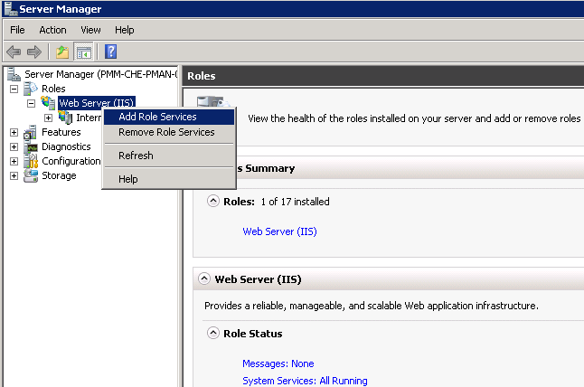

1. In the **Add Role Services** dialog:

* Select **FTP Server** under **Roles Services**.
* Ensure **IIS Management Console** is checked under **Management Tools**.

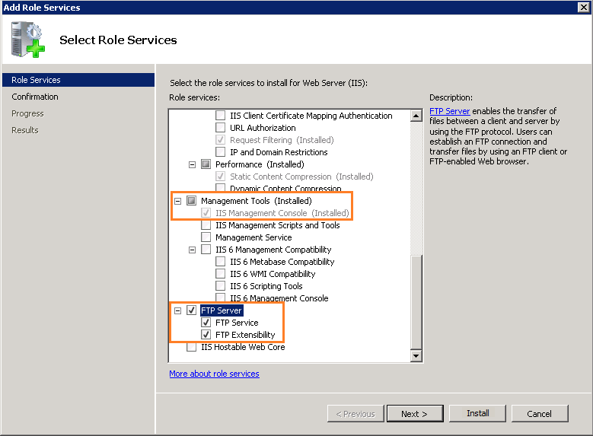

1. Click **Next > Install**, and wait for the installation to finish.

### **Creating an FTP Site**

1. Go to **Start > Administrative Tools > Internet Information Services (IIS) Manager**.
2. In IIS Manager, expand the local server node.
3. Right-click on **Sites** and select **Add FTP Site**.
4. In the **Add FTP Site** wizard:
   * Enter a **Site Name** and **Physical Path** to the directory where files will be stored/shared.

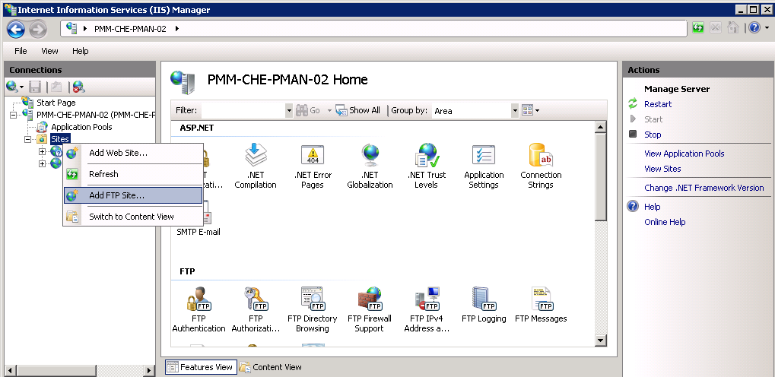

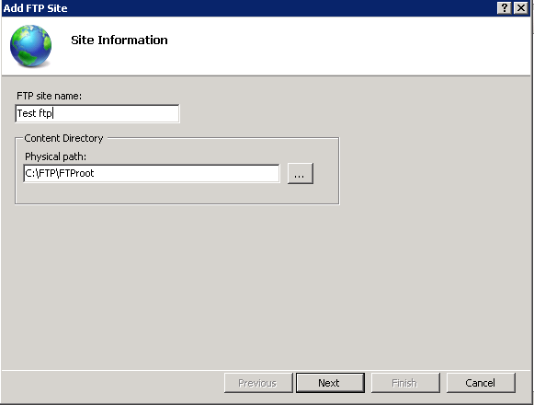

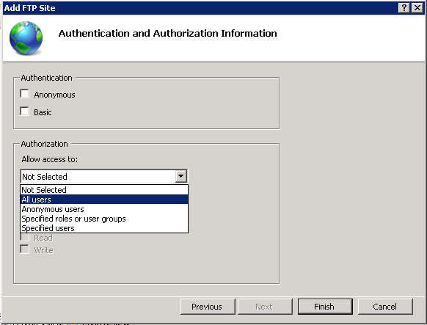

1. In **Binding and SSL Settings**:
   * Choose the **IP address** of the server.
   * Enable **Start FTP Site Automatically**.
   * Choose **No SSL** or **SSL Based on Constraint** depending on your environment.
2. Click **Next**.

### **Configuring FTP Authentication & Authorization**

1. In the **Authentication settings**, select **Basic**.
2. In the **Authorization settings**:
   * Choose **All Users** (or specific users).
   * Check **Read** and **Write** permissions.
3. Click **Finish** to complete FTP site creation.

### **Accessing FTP Site from Client System**

1. On a client PC within the same LAN, open **File Explorer**.
2. In the address bar, type:  
   ftp://<server-IP-address>  
   Example: ftp://192.168.1.100
3. Enter the **Username** and **Password** (Windows credentials).

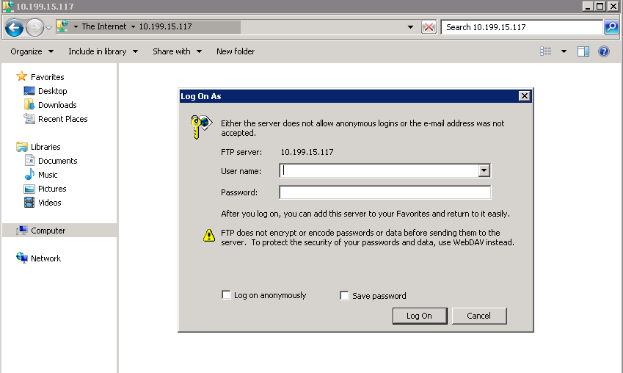

1. Once authenticated, files and folders shared through the FTP server will be displayed.
2. Users can now **upload/download** files depending on the permissions set.

## **RESULT:**

Thus the FTP service was successfully installed and configured using IIS.

| **EX.NO: 7** | **NETWORK CABLING AND TESTING** | **Date:** |
| --- | --- | --- |

## **AIM:**

To understand and practice the process of creating and testing network cables including cable crimping, standard (straight-through) cabling, cross cabling, and verifying functionality using a cable tester.

## **REQUIREMENTS:**

| **Item** | **Quantity** |
| --- | --- |
| RJ-45 Connectors | As needed |
| Cat5e/Cat6 UTP Cable | 1–2 meters per cable |
| Crimping Tool | 1 |
| Cable Tester | 1 |
| Wire Stripper | 1 |
| Network Diagrams | Optional |
| System with NIC card | 2 (for testing cross cable) |

### **PROCEDURE:**

### **A. Cable Crimping**

1. Cut the UTP cable to the required length.
2. Strip approximately **1 inch (2.5 cm)** of the outer insulation from both ends.
3. Untwist and arrange the 8 wires according to the wiring standard:
   * **T568A** or **T568B**.
4. Flatten and trim the wires to equal length.
5. Insert the wires carefully into the RJ-45 connector (metal pins facing up).
6. Ensure wires are fully inserted and in correct order.
7. Insert the connector into the crimping tool and press firmly to crimp.
8. Repeat the above steps for the other end of the cable.

### **B. Standard Cabling (Straight-Through Cable)**

* **Used for**: Connecting different devices (e.g., PC to switch, router to PC).
* Use the **same standard (T568B - T568B)** on both ends.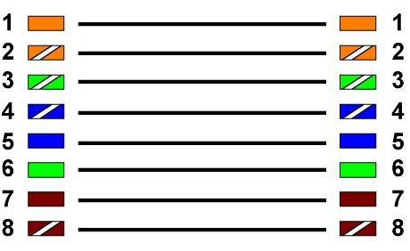

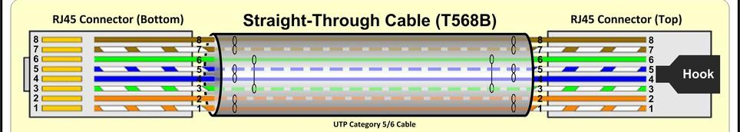

1. Take 1-meter length of CAT 5/6 UTP cable.
2. Using wire strippers, remove about 3 cm of the outer insulating jacket at each end
3. Separate each pair of wires and put them in the correct order of sequence.
4. Trim the wires to about 1.5 cm from the outer insulating jacket.
5. With the hook side of the RJ45 connector facing down, slide the wires all the way into the Connector. Push the outer insulating jacket into the connector just past the first crimping Point.
6. Place the RJ45 connector into the crimping tool. Firmly pull the handle of the tool until the Wires are crimped into place.
7. The connector should crimp each of the wires tightly, and the connector should bind the Outer jacket.
8. To make a complete cable, repeat the steps above and add a connector to the other end.

### **C. Cross Cabling (Crossover Cable)**

* **Used for**: Connecting similar devices (e.g., PC to PC, switch to switch).
* Use **T568B on one end and T568A on the other**.



1. Start with an approximately 2-meter length of CAT5/6 UTP cable.
2. Using wire strippers, remove about 3 cm of the outer insulating jacket at each end.
3. Separate each pair of wires on one end and put them in the correct order of sequence
4. Snip the wires to about 1.5 cm from the outer insulating jacket.
5. With the hook side of the RJ45 connector facing down, slide the wires all the way into the connector. Push the outer insulating jacket into the connector just past the first crimping point
6. Place the RJ45 connector into the crimping tool. Firmly pull the handle of the tool until the wires are crimped into place.
7. The following figure can be representing the cross over cabling method

### **D. Testing the Crimped Cable Using a Cable Tester**

1. Insert both ends of the cable into the **main unit** and **remote unit** of the cable tester.
2. Power on the tester.
3. Observe the LED indicators on both units:
   * All 8 LEDs should light up in correct sequence.
   * If any LED fails or is out of order, the cable has a fault (e.g., miswiring, break).
4. Record the result (PASS/FAIL).

## **RESULT:**

Thus the cables are successfully crimped and tested as Straight-through cable for connecting different devices, Cross-over cable for connecting similar devices and verified connectivity and correct wiring using a cable tester.

| **EX.NO: 8** | **NETWORK TOPOLOGY DESIGN USING SIMULATION SOFTWARE** | **Date:** |
| --- | --- | --- |

**AIM:** To design and simulate a basic network topology using network simulation software to understand how devices communicate within a network.

## **REQUIREMENTS:**

| **Item** | **Description** |
| --- | --- |
| Software | Cisco Packet Tracer / GNS3 / NetSim |
| Devices (in software) | PCs, Switches, Routers, Cables |
| Network Protocols | IPv4 |
| OS | Windows/Linux (optional) |

## **PROCEDURE:**

### Open the Simulation Software

* Launch **Cisco Packet Tracer** or any other simulation tool installed on your system.

### Create Network Topology

**Step 1: Select and drag devices**: 6 PCs, 1 Switch

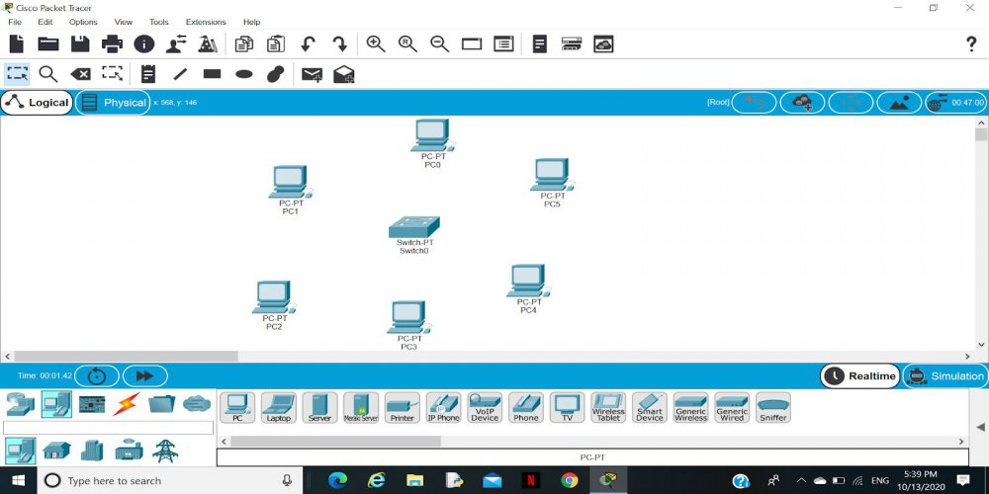

**Step 2:** Link every device with the switch.

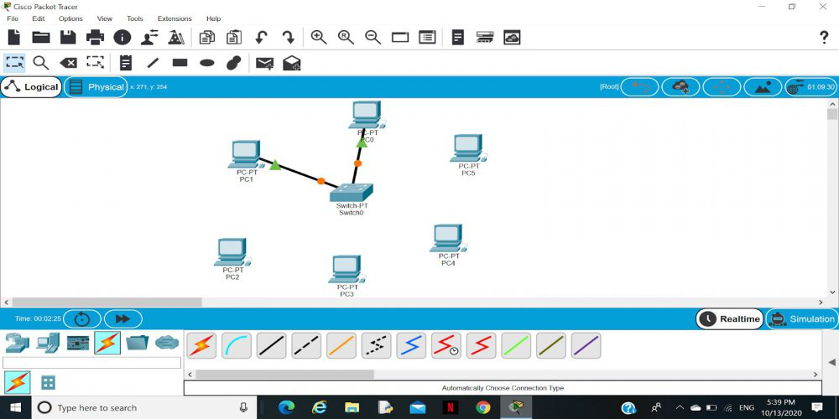

**Step 3:**Provide the IP address to each device.

* Click on **PC1**, go to **Desktop > IP Configuration**.
* Assign an IP address (e.g., 192.168.1.1) and subnet mask (255.255.255.0).
* Repeat for **PC2** with IP: 192.168.1.2.

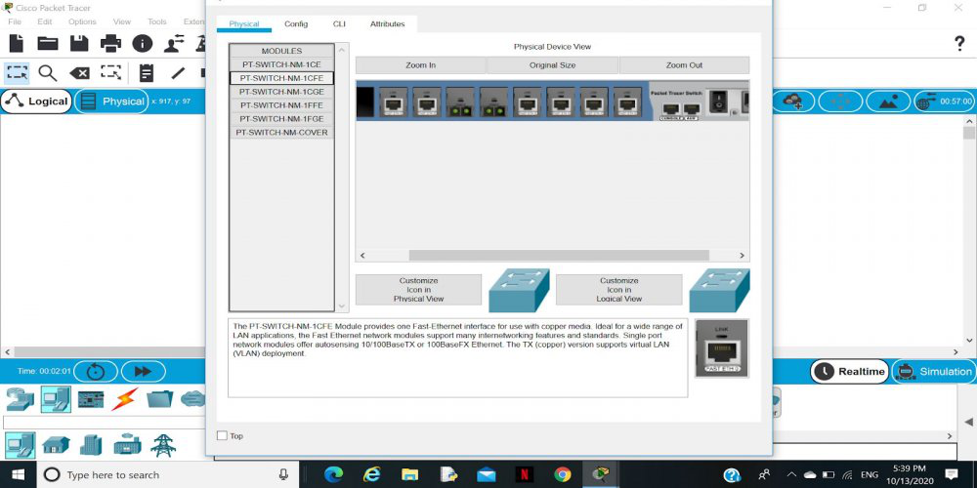

**Step 4:**Transfer message from one device to another and check the Table for Validation.

* Use **ping command** from **PC1 to PC2**:
* Go to PC1 > Desktop > Command Prompt
* Type ping 192.168.1.2
* Check the reply messages. If packets are received, the network is successfully connected.

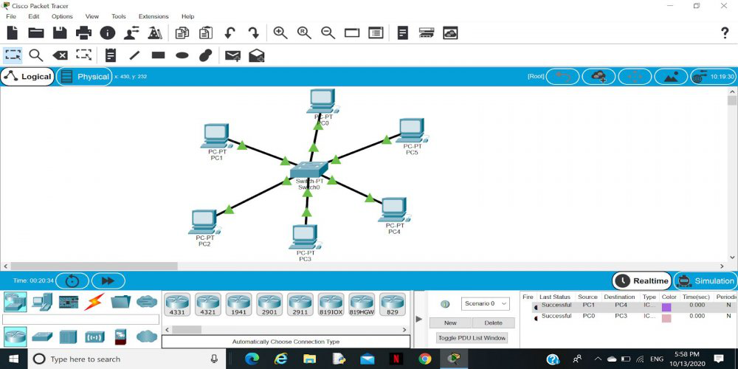

**RESULT:**

Thus, a network topology was successfully created and tested using network simulation software, demonstrating effective configuration and connectivity between networked devices.

| **EX.NO: 9** | **IP CONFIGURATION AND NETWORK DEBUGGING USING COMMAND-LINE UTILITIES** | **Date:** |
| --- | --- | --- |

## **AIM:**

To configure IP address settings manually and use command-line utilities like ipconfig, ping, tracert, and netstat to test and debug network connectivity in a LAN environment.

## **PROCEDURE:**

### **A. Configure Host IP, Subnet Mask and Default Gateway**

#### 1. Manual IP Configuration

1. Click **Start > Control Panel > Network and Internet Connections**.
2. Double-click **Network Connections > Local Area Connection**.
3. In the **Local Area Connection Properties** window, select **Internet Protocol (TCP/IP)** and click **Properties**.
4. Choose **Use the following IP address**.
5. Enter the following:
   * **IP Address**: 192.168.1.2
   * **Subnet Mask**: 255.255.255.0
   * **Default Gateway**: 192.168.1.1
6. Choose **Use the following DNS server address** if required by your ISP.
7. Click **OK** to apply settings.

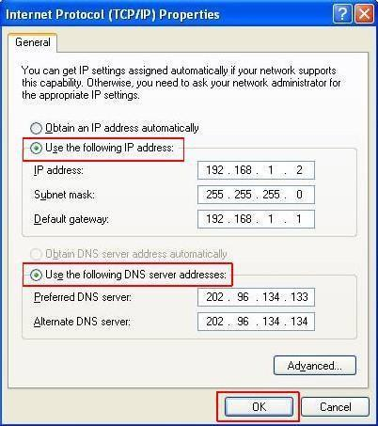

#### 2. DHCP-based IP Configuration

* Select **Obtain an IP address automatically** and **Obtain DNS server address automatically** to use DHCP (Dynamic Host Configuration Protocol).

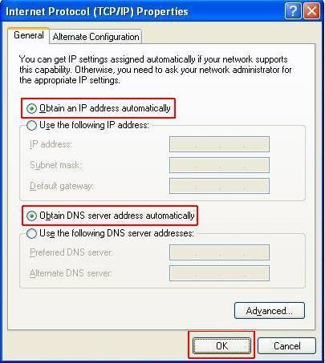

### **B. Use of Network Debugging Utilities**

#### 1. IPCONFIG

* Launch **Command Prompt**: Start > Run > type: cmd > Press Enter
* Type the following command:

*ipconfig*

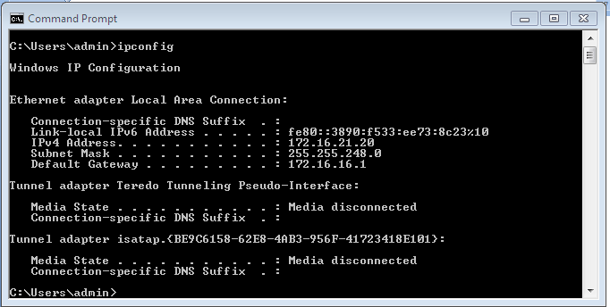

#### 2. PING

* To test connectivity to another system or internet:

*ping 192.168.1.1* (for gateway)

*ping 192.168.1.10* (for peer)



#### 3. TRACERT

* To trace the path taken by packets:

*tracert* [*www.google.com*](http://www.google.com)



#### 4. NETSTAT

* To view active connections and network stats:

*netstat –a*

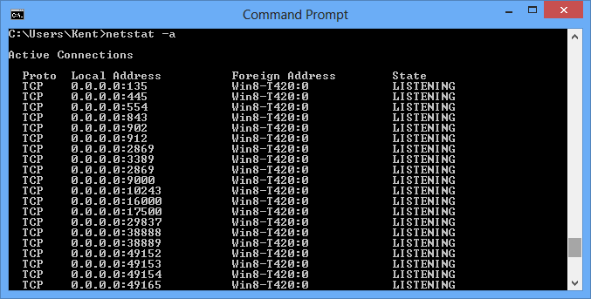

**RESULT:**

Thus the Host IP, Subnet Mask and Default Gateway in a system in LAN (TCP/IP) Configured and Internet connection utilities IPCONFIG, PING / Tracert and Netstat commands are used to debug the Network issues.

| **EX.NO: 10** | **USER ACCOUNT CONFIGURATION, AUTOMATED BACKUP, AND FIREWALL RULE SETUP IN WINDOWS** | **Date:** |
| --- | --- | --- |

## a) Creating and Configuring User Accounts

### **AIM:**

To create Administrative and Standard user accounts in Windows and configure their access.

### **PROCEDURE:**

1. **Open Settings → Accounts → Family & other users**
2. Click **Add someone else to this PC**.
3. Choose "I don’t have this person’s sign-in information" → "Add a user without a Microsoft account".
4. Enter username & password. Click **Next**.
5. Select the account → Click **Change account type**.
   * Choose **Administrator** or **Standard User**, then click OK.

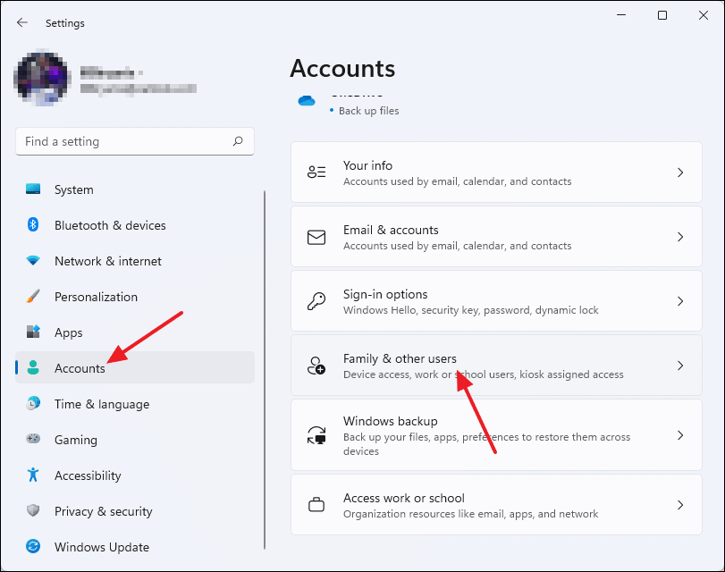

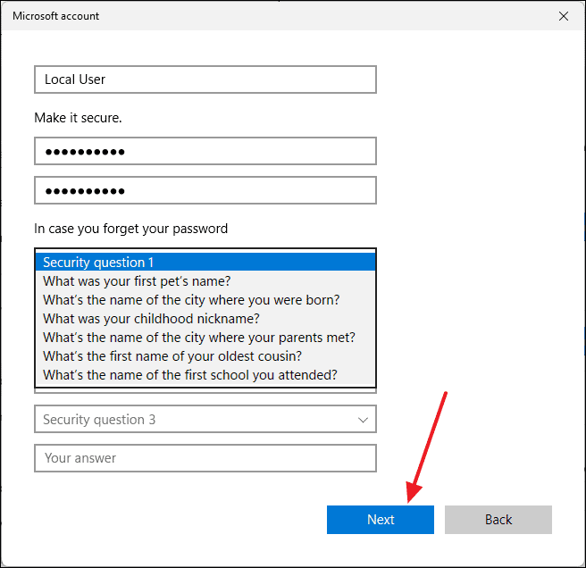

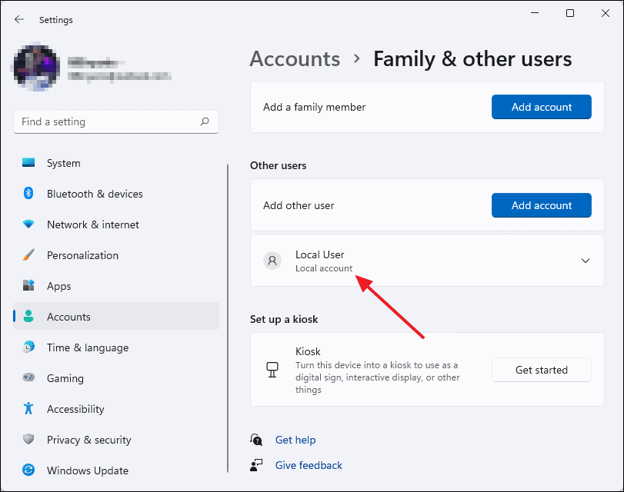

## b) Create Automated Backups

### **AIM:**

To set up automatic backups of important data using Windows Backup or Task Scheduler.

### **PROCEDURE:**

### **Using File History (GUI)**

1. Go to **Control Panel → File History**.
2. Click **Turn On** (connect external or network drive).
3. Click **Select Drive** to set destination.
4. Use **Advanced Settings** to configure frequency and size.

### **Using Task Scheduler (for folder backup)**

1. Open **Task Scheduler** → Create Basic Task.
2. Name: “Daily Folder Backup”.
3. Trigger: **Daily**, set preferred time.
4. Action: **Start a program**
5. Finish the wizard.

## c) Configure Firewall Rules for Server Access

### **AIM:**

To configure Windows Firewall to allow incoming connections for server applications.

### **PROCEDURE:**

1. Open **Windows Defender Firewall with Advanced Security**.
2. Click **Inbound Rules** → **New Rule**.
3. Select **Port** → Click **Next**.
4. Choose **TCP** or **UDP** and enter port number used by the server (e.g., 445 for SMB).
5. Allow the connection → Click **Next**.
6. Select the profiles (Domain, Private, Public) → **Next**.
7. Name the rule: "Allow Server Service".

## **RESULT:**

Thus, user accounts were successfully created, automated backups were scheduled, and firewall rules were configured to enable secure client-server communication.